High Court of Australia

How to download an invoice
If you wish to download a copy of an invoice issued for a filing or hearing fee or for an inspection or copying fee it will be available in the “Payments” area of your DLS Portal.

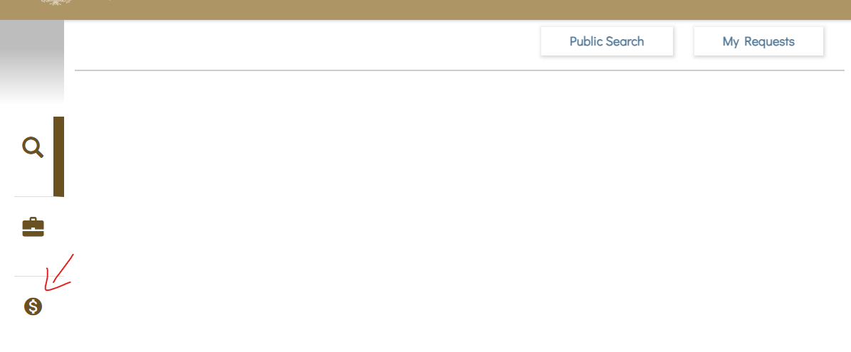

There will be a list of cases and invoices associated with those cases. The list will show both paid and pending invoices. If you have an invoice on which you applied for a fee waiver which was approved the invoice is deactivated and is removed from this list.

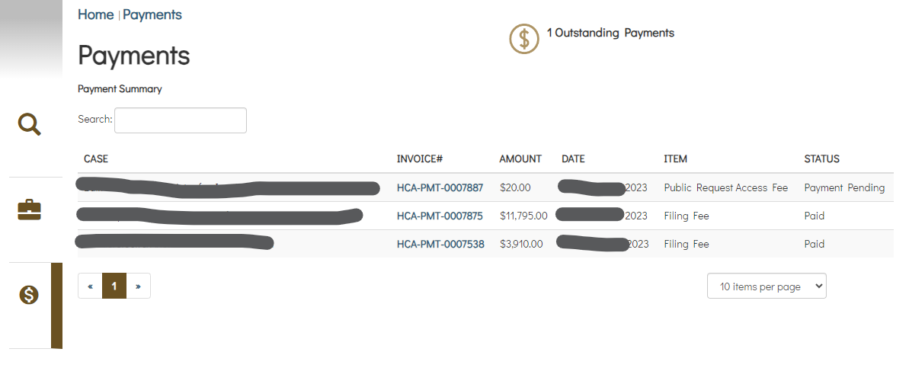

To access one of the invoices click onto the invoice number listed.

This opens the payment screen. You can download copies of paid and pending invoices.

Pending invoices include the credit card payment options:
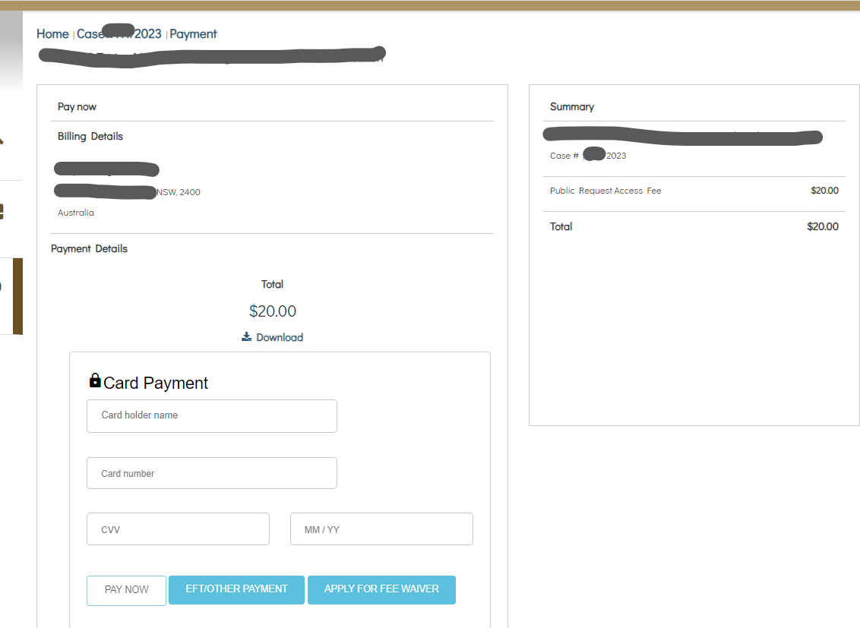

Paid invoices allow you to download a copy of the paid invoice:

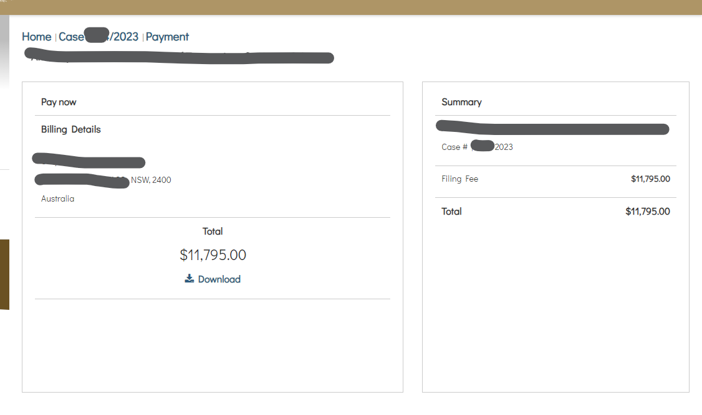

Paid invoices are marked as paid.

